**FLEET APP version 1.6 concerns**

LOGISTICS HEAD

1. New SO / New PO / New ITR nudges. Why all of them have transaction numbers already?

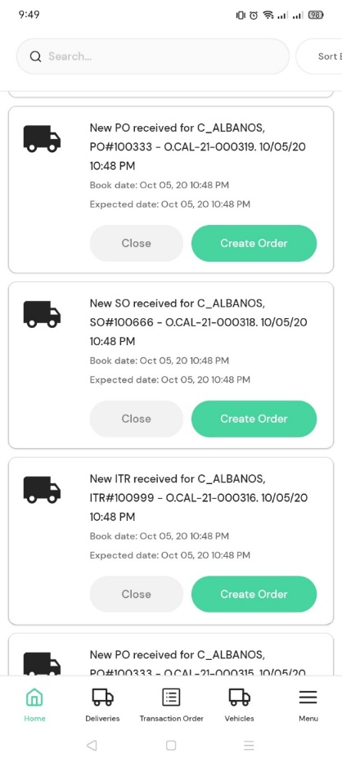

1. Why after transaction order creation goes directly to create delivery immediately?
2. Destination POI is not showing in Transaction order details if the transaction type is JPSC SALES TRANSACTION.

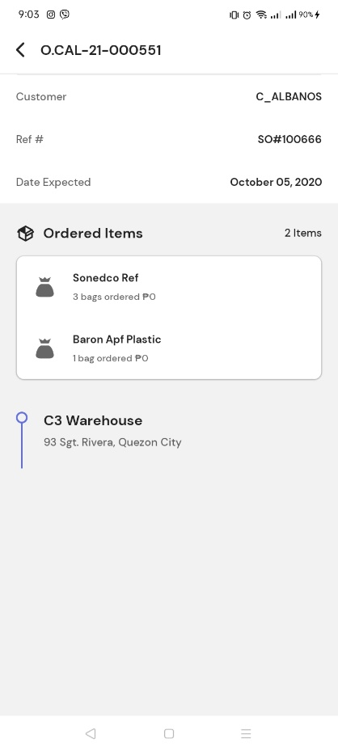

1. Accidentally selected a wrong Delivery date, I want to select the date today but I can’t select the date today.
2. Set time earlier than the time of creation is not allowed.
3. Edit Delivery. Shows only one transaction order.

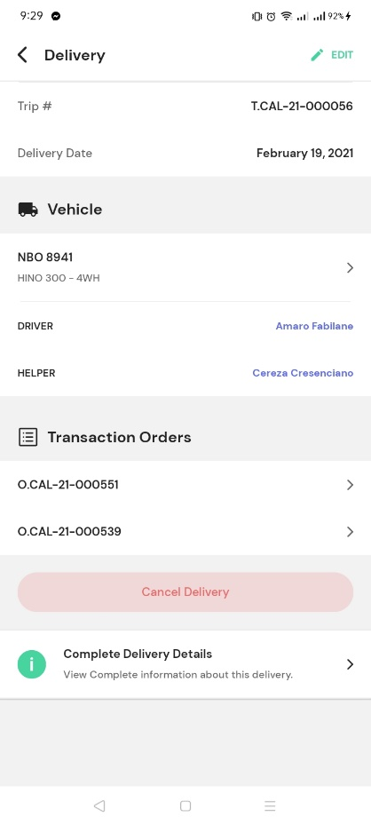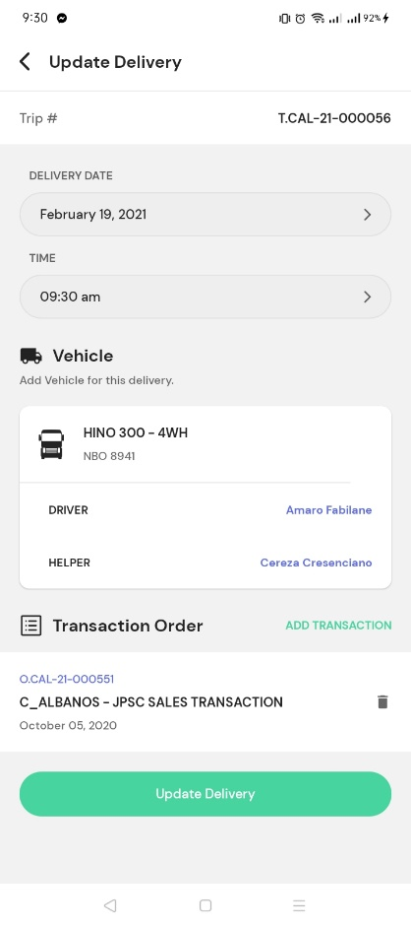

1. How to cancel available transaction order?

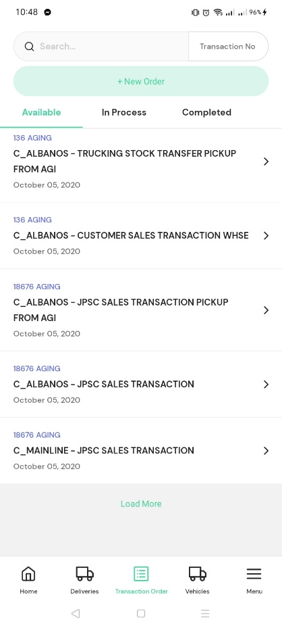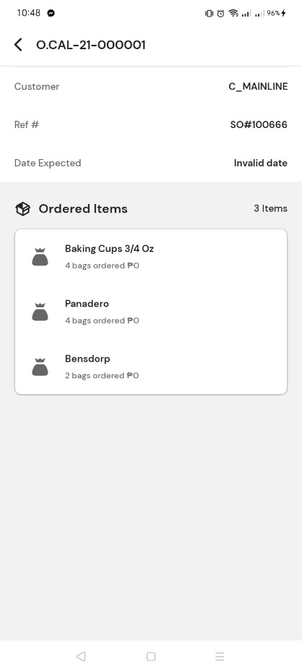

1. Cannot update delivery details.

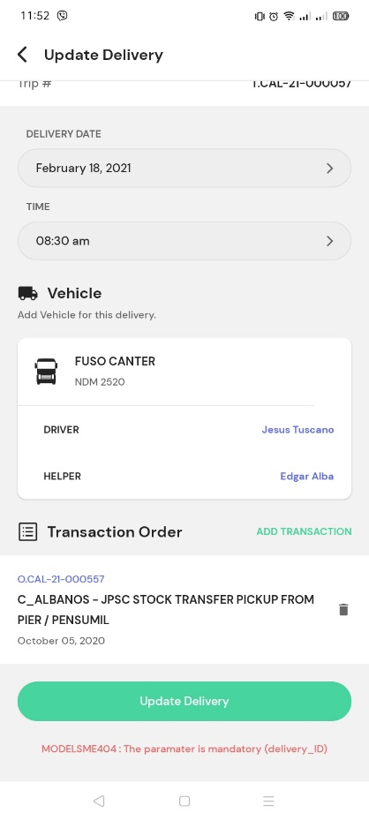

1. Custom Transaction Order. SO & PO

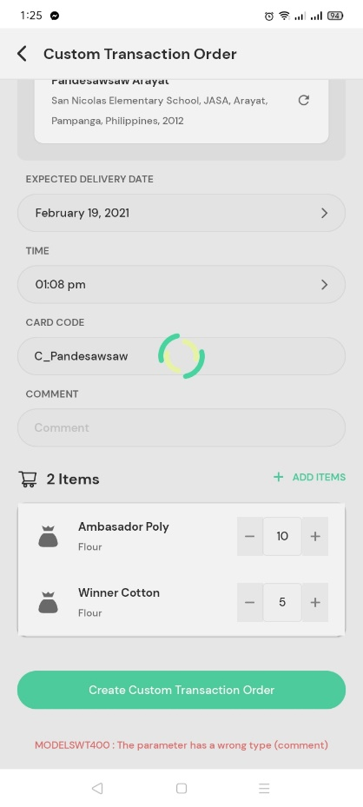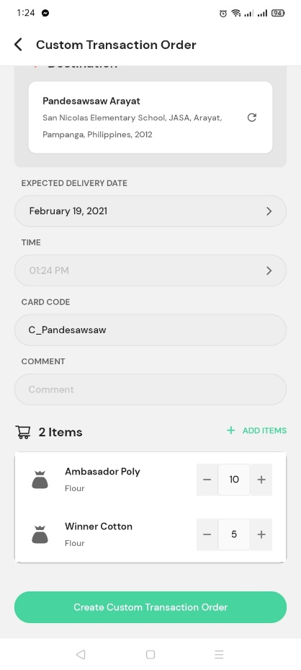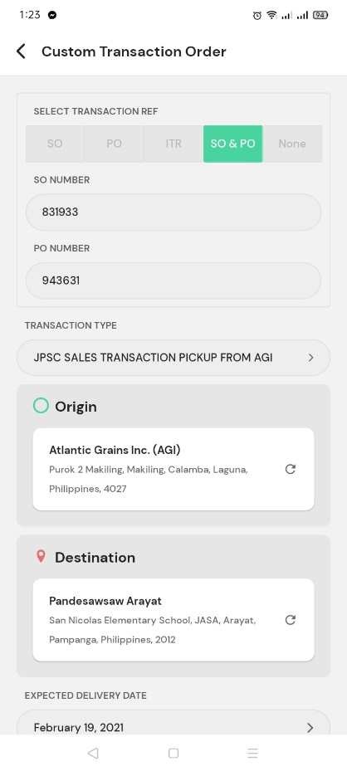

Remove time. (unnecessary)

Change manual input to select recipient from tblcustomer

Error creating Custom Transaction order.

Expected Delivery Date is automatically set for tomorrow. Cannot select date today.

1. Create JPSC TAXI using Custom Transaction Order.

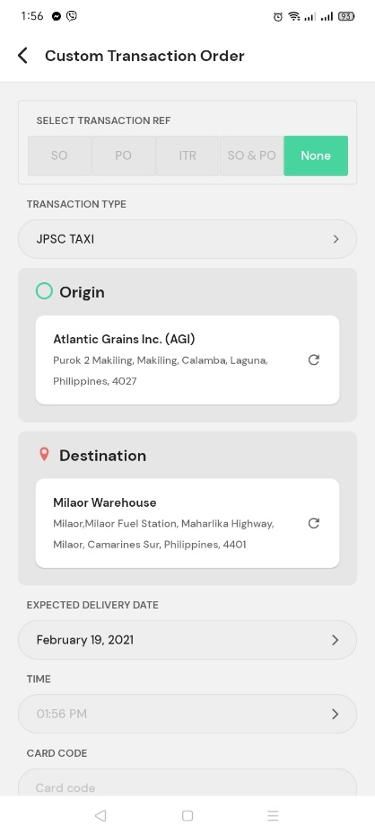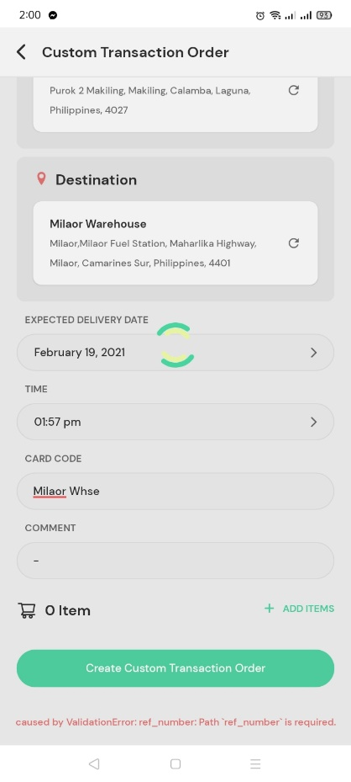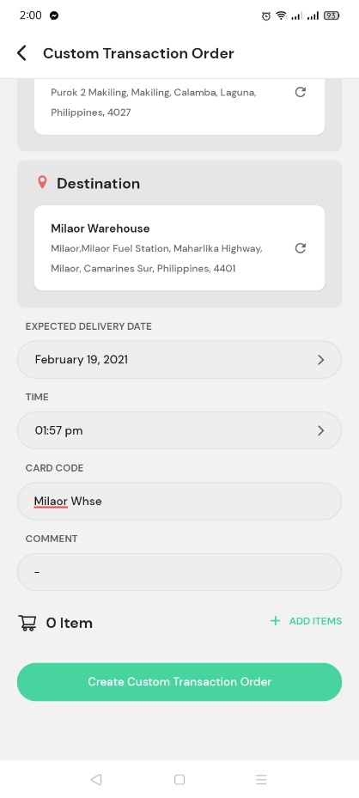

Expected Delivery Date is automatically set for tomorrow. Cannot select date today.

Remove time. (unnecessary)

Change manual input to select recipient from tblcustomer

Error creating Custom Transaction order.